STUDENT APPLICATION

Student Name
Student ID DOB
Current Campus Grade
2017-2018 Zoned Campus
Parent/Guardian Name
Address
Phone Numbers /
Overall average for Math end of 4th six weeks:
Overall average for Science end of 4th six weeks:
Attach:
1) Copy of 4th six weeks report card.
2) Recommendation letters from current math and science teacher.
Commitment to STEM Program: Must be signed by parent and student.
- We commit to maintaining an 85% average per semester in both STEM math and STEM science classes.
- We commit to completing/competing in at least one (Science Fair, Brainsville, American Math, Math Counts, Robotics or other district supported math or science) competition.
- We commit to maintaining over a 98% attendance rate.
- We commit to maintaining an outstanding code of conduct record.
- We commit to attending parent-teacher-student-principal conferences as required to discuss grades, probation status, contracts for improvement, and all other meetings deemed necessary by the school to remain in the STEM Program.
- Failure to maintain any or all of these commitments may result in probation and or removal from the program.

/ /
Parent/Guardian Signature Student Signature Date
Application Deadline: Friday, March 3, 2017
Submit application to your campus grade level counselor.

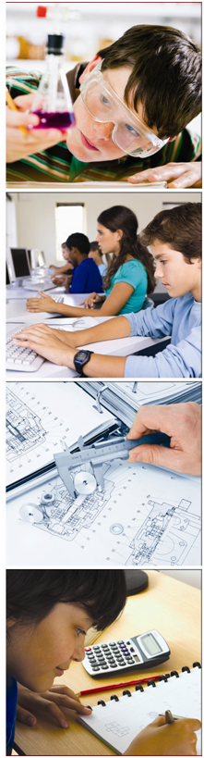
Science
Technology
Engineering
Mathematics
2017-2018
Middle School
STEM Application
Brownsville Independent
School District

CURRICULUM

The BISD Middle School STEM Program reinforces math and science through mechanical, civil, environmental, biomedical, and aerospace engineering. Students apply concepts through hands-on design projects such as building robots, rockets, and research on topics such as simple machines, heredity and astronomy. Upon completion of the program, students are well prepared to succeed in STEM coursework and earn the STEM Endorsement upon high school graduation.

Students are strongly encouraged to use this program to prepare for and apply to BISD’s Science, Technology, Architecture, and Medical Professions (STAMP) Programs or STEM Programs for Aerospace and Careers in Engineering (SPACE) Academies in high school.

Students must successfully complete Algebra I to be able to apply for STAMP program or SPACE academy.

ELIGIBILITY CRITERIA

- Priority I: 85% or above overall average in Math and Science at the end of current year 4th six weeks.
- Priority II: 80-84% overall average in Math and Science at the end of current year 4th six weeks.
- Recommendation letters from both current math and science teachers.
- Parent and student signature on commitment statement.
- Parent and student participation in orientation meeting held at the middle school campus.
- STAAR math score may be considered if student does not meet grade requirement.
Final acceptance based on the Middle School Committee (principal, counselor, STEM math and science teachers) and space availability.
BISD does not discriminate on the basis of race, color, national origin, sex, religion, age, disability or genetic information in employment or provision of services, programs or activities.
BISD no discrimina a base de raza, color, origen nacional, sexo, religión, edad, incapacidad o información genética en el empleo o la disposición de servicios, programas o actividades.

Application Deadline: Friday, March 3, 2017
Submit application to campus grade level counselor.

BISD MIDDLE SCHOOL
STEM CURRICULUM TOPICS

- Engineering Design
- STEM Careers
- Simple Machines
- Rocketry and Star Research
- Robotics – LEGO® MINDSTORMS® NXT and EV3
- Sensors
- Human Body Systems & Heredity
- Structures
- Investigating Newton’s Laws
- Civil Engineering – Water Distribution
* Curriculum Topics subject to change.

STEM STATISTICS
- Between 2014 and 2024, the number of STEM jobs will grow 23% in Texas (17 percent nationally), as compared with 12 percent for non-STEM jobs.
- In 2012, the median earnings for workers in STEM occupations (regardless of education level or field) were $78,270, more than double the median ($34,750) for all U.S. workers.
- STEM related jobs have the lowest unemployment rates.
- Of the 20 fastest growing occupations projected, 15 of them require substantial math or science preparation.

